俊风汽车有限公司
JunFeng Automobile Co.,Ltd
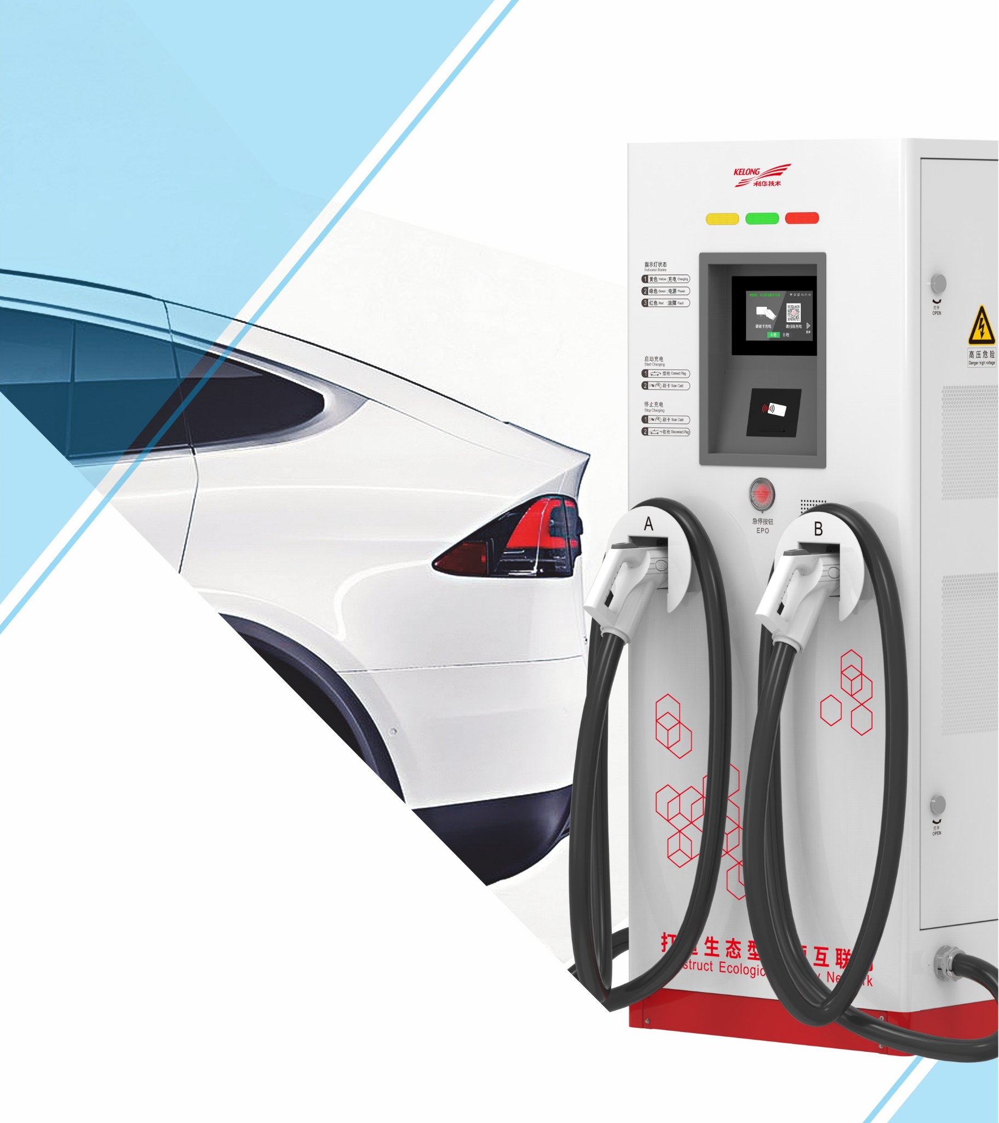

All-in-one DC charger
（EVD751-120K-TD）
Technical Specification
Quote

一、产品概述 product overview
一体式直流充电机由充电模块、控制系统、充电接口、人机交互、通信、计费等组成；设备可根据车辆BMS反馈的数据，动态调整充电参数，实现智能充电，广泛适用于各类充电应用场景。
The integrated DC charger is composed of charging module, control system, charging interface, human-computer interaction, communication, billing, etc. The device can dynamically adjust the charging parameters according to the data fed back by the vehicle BMS to realize intelligent charging, and is widely applicable to various types of charging. application scenarios.

二、适用范围 Scope of application
服务车型：适用于具备国标直流充电接口的车辆，如新能源纯电动公交车、乘用车、物流车、特种车辆等。
Service models: suitable for vehicles with national standard DC charging interfaces, such as new energy pure electric buses, passenger cars, logistics vehicles, special vehicles, etc.

使用场景：适用于集中式充电站（如专用充电站、公共充电站等）以及分散式充电站（如小区、综合办公楼、主题公园、4S店等）。
Usage scenarios: It is suitable for centralized charging stations (such as dedicated charging stations, public charging stations, etc.) and decentralized charging stations (such as communities, comprehensive office buildings, theme parks, 4S stores, etc.).

满足标准： GB/T 18487.1-2015、GB/T 20234.1-2015、GB/T 20234.3-2015、GB/T 27930-2015
fulfill the standard:
GB/T 18487.1-2015, GB/T 20234.1-2015, GB/T 20234.3-2015, GB/T 27930-2015

外观尺寸 Appearance size
一体式直流充电机（EVD751-120K-TD）外观及尺寸如图1所示：
The appearance and size of the integrated DC charger (EVD751-120K-TD) are shown in Figure 1:
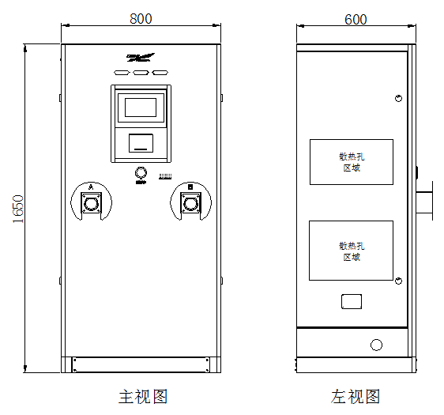
图 1一体式直流充电机（EVD751-120K-TD）外观及尺寸图
Figure 1 Appearance and dimensions of the integrated DC charger (EVD751-120K-TD)

主要技术指标 Main Specifications
一体式直流充电机（EVD751-120K-TD）技术指标如表3所示：
The technical indicators of the integrated DC charger (EVD751-120K-TD) are shown in Table 3:
型号model  参数 parameter |  | EVD751-120K-TD
产品名称 product name |  | 120kW双枪一体式直流充电机Dual Gun Integrated DC Charger
输入  enter | 工作电压Working voltage (VAC) | 380V (三相五线制，3W+N+PE)±20%
 | 频率范围Frequency range (Hz) | 45~66
 | 功率因数power factor | ≥0.99
输出  output | 充电接口（个）Charging interface (pcs) | 2
 | 输出电压范围Output Voltage Range (VDC) | 200~750
 | 输出功率Output power (kW) | 120
 | 充电枪长度Charging gun length (m) | 5
 | 功率分配方式Power distribution method | 120/0；60/60；0/120
设备信息Device Information | 冷却方式cooling method | 风冷air cooling
 | 最高效率highest efficiency | ≥95.5 %
 | 噪音Noise (dB) | ＜65
 | 防护等级Protection class | IP54
 | 尺寸size（W×D×Hmm） | 800×600×1650

